**FESTIVAL EVENT REGISTRATION**

**SYSTEM**

**TABLE OF CONTENTS**

**SL NO CONTENTS PAGE NO**

1Abstract 3

2 Introduction 4

3 Requirement Specifications 5

4 Architecture Design 10

5 Conclusion 11

6 References 12

**ABSTRACT**

This is an Online event Registration system software project that serves the functionality of an event manager. The system allows only registered users to login and new users are allowed to resister on the application. This is a web application developed in JAVA and SQL. The project provides most of the basic functionality required for an event. It allows the user to select from a list of event types. Once the user enters an event type the system then allows the user to register for an Event. If the user wants to cancel the registration he can do and he can register to the another event. All this data is logged in the database and the user is given a receipt number for his booking. This data is then sent to the administrator (website owner) and they may interact with the client as per his requirements and his contact data stored in the database.

**INTRODUCTION**

Festival Event Registration System is one of the most rapidly growing majors in the country.

This project performs the task of developing a web application that enables the users to register the data very easily. The main purpose of festival event registration system is to provide a platform for the users to register and view the information about the events which are about to take place in the upcoming festival. They can first register into the website and see through the information such as details about the events like the venue, theme of the event, participants, etc. The user can then login to see his/her profile. The registered candidate’s information are recorded and stored in database. The user can login and update the information, delete any unwanted data, arrange the information accordingly so that the user can go through a user friendly and know all the whereabouts of their events in the festival.

**SOFTWARE REQUIREMENT SPECIFICATION**

**Hardware requirements**

The Hardware Requirements are:

* RAM:8GB
* Processor:Intel(R) Core(TM) i5-3320M CPU @ 2.60GHz 2.60GHz

**Software Requirements**

The software requirements are:

* Operating System – Windows
* Front End – JSP,Servlet,Hibernate,JSTL,Cloud
* Front End Tool – Eclipse, STS
* Back End – My SQL
* Web Server – Apache Tomcat 8

**ARCHITECTURE DESIGN**

**Project Modules**

**Registration:** Participants can register online for taking part in events of the festival.

**Login:** Participants who have already registered can login.

**Event Registration:** Participants can register into events from event catalog.

**Event Deregistration:** Participants can unregister from events in the event catalog.

**Update:** Participants can update their information.

**3.2 Use Case Diagrams**

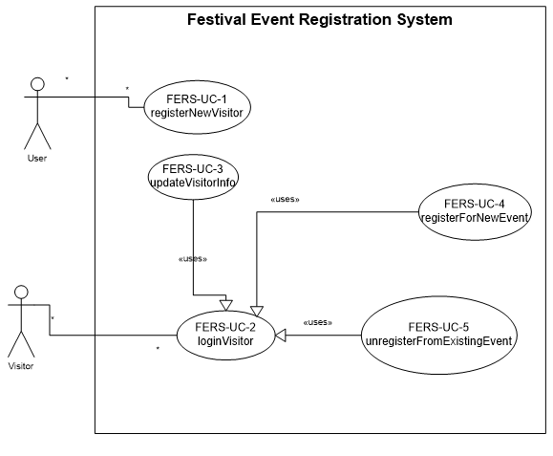

Register Visitor

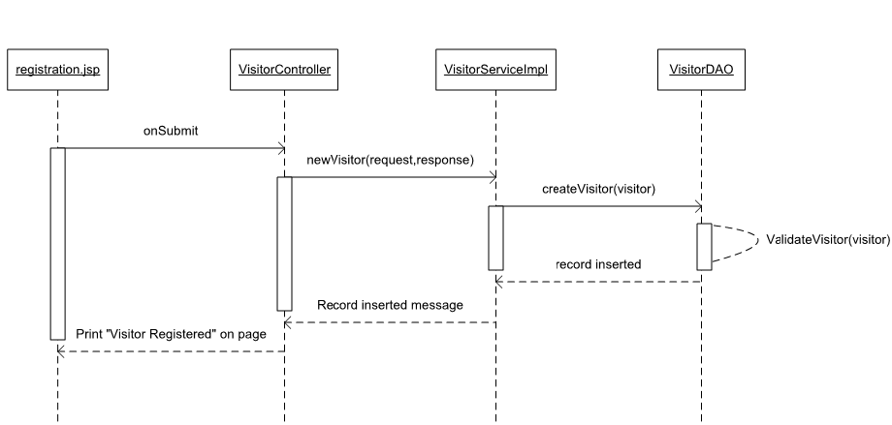

Login Visitor

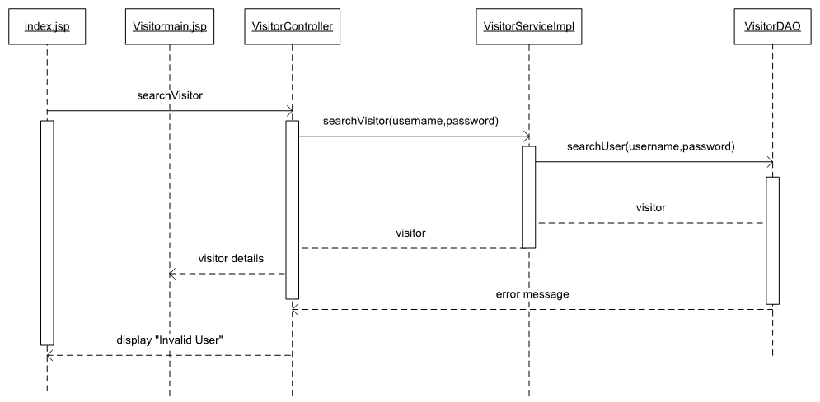

Update Visitor

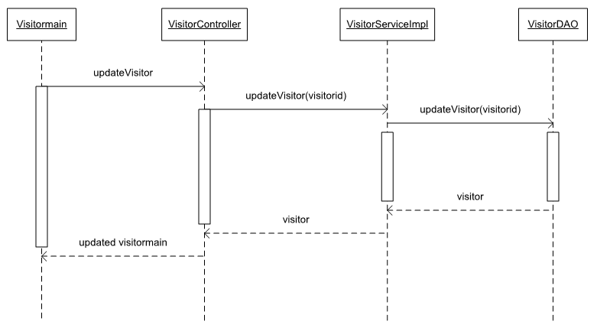

Register Event Visitor

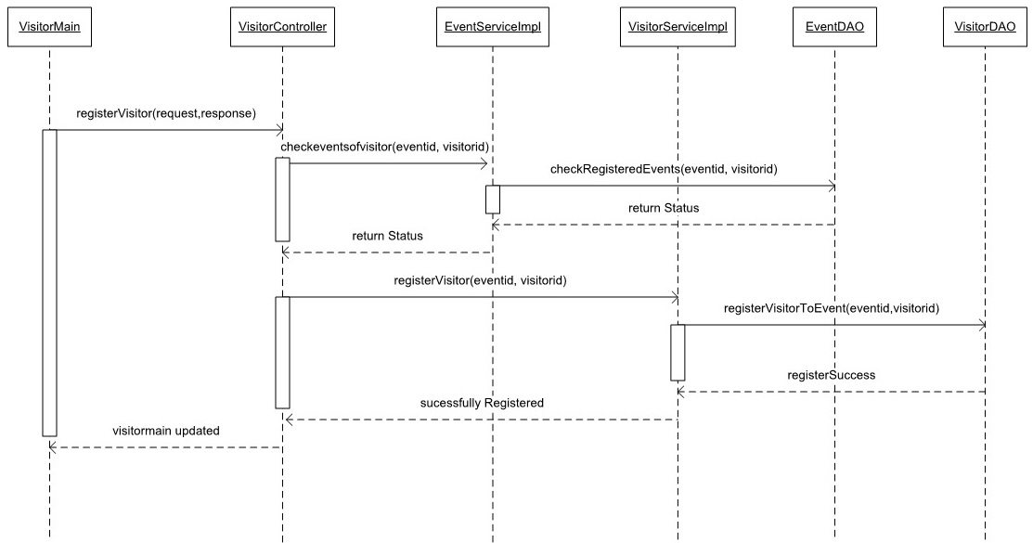

Unregister Event Visitor

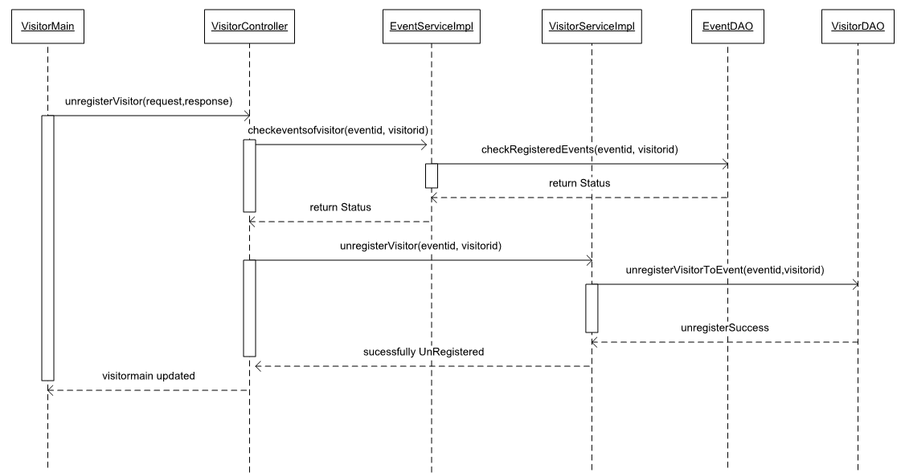

**Conclusion**

This project was successfully completed, within the time span allotted. All the modules are tested separately and input together to form the main system. Finally the system is tested with real data and everything worked successfully. Here, management of registration form and evaluation is done very efficiently as a result of which the project has a good scope.

**References:-**

* <https://blog.capterra.com/8-free-and-open-source-event-registration-software/>
* <https://medium.com/hubilo-officil-blog/12-online-platforms-to-get-your-event-registrations-in-place-de7ab9c4e577>
* <https://spring.io/>
* <https://www.google.com/search?q=html+and+css+projects&oq=html+and+css&aqs=chrome.1.69i57j0l5.4614j0j7&sourceid=chrome&ie=UTF-8>
* <https://www.google.com/search?q=mysql&oq=mysql&aqs=chrome.0.69i59l2j69i65j69i60j0l2.1414j0j7&sourceid=chrome&ie=UTF-8>